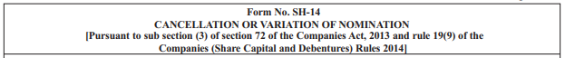
To

KFin Technologies Private Limited
Unit: Chennai Petroleum Corporation Limited (CPCL)
Selenium Buildings, Tower – B,
Plot No.31-32, Gachibowli, Financial District,
Nanakramguda,
Hyderabad – 500 0332

7. The nomination form filled in “duplicate” should be lodged with the Registrar and Share Transfer Agent of the Company, i.e. M/S.KFin Technologies Private Limited, Selenium Buildings, Tower – B, Plot No.31-32, Gachibowli, Financial District, Nanakramguda, Hyderabad – 500 032. The registrar will return one copy of the nomination form to the shareholder after registering the nomination. The registration number allotted will be furnished to the surviving shareholders.
